EXPERMENT NO.1
Question 1: Write the basic HTML5 document structure and implement all six heading tags (<h1>to<h6>) with sample text.
Code:
<html>
<head>
<title> 2610997070 </title>
<body>
<h1> this is heading 1 </h1>
<h2> this is heading 2 </h2>
<h3> this is heading 3 </h3>
<h4> this is heading 4 </h4>
<h5> this is heading 5 </h5>
<h6> this is heading 6 </h6>
</body>
</html>
Output:
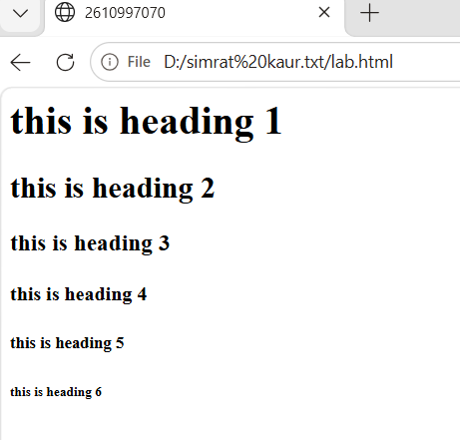

EXPERIMENT NO.2
Question 2: Create a paragraph and apply text formatting tags (<b>, <i>, <u>, <strong>, <em>) to given content.
Code: <html>
<HEAD>
<TITLE> 2610997070 </TITLE>
</HEAD>
<BODY>
<p>
This is a <b>bold</b> word, <br>
This is an <i>italic</i> word, <br>
this is an <u>underlined</u> word, <br>
this is an <strong>important</strong> text,
<br>
and this is <em>emphasized</em> text, <br>
</p>
</BODY>
</html>
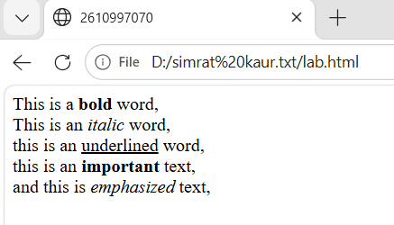

EXPERIMENT NO.3
Question 3: Create an ordereded list (<ol>) for a recipe’s steps and an unordered list (<ul>) for its ingredients on the same page.
Code :
<HTML>
<HEAD>
<TITLE> 2610997070 </TITLE>
</HEAD>
<BODY>
<h2>Recipe: Maggi</h2>
<h3>Ingredients</h3>
<ul>
<li>Maggi noodles</li>
<li>Water</li>
<li>Maggi masala</li>
<li>Vegetables</li>
</ul>
<h3>Steps</h3>
<ol>
<li>Boil water in a pain.</li>
<li>Add the Maggie noddles.</li>
<li>Add the masala and vegetables.</li>
<li>Cook for 2-3 minutes.</li>
<li>Serve hot.</li>
</ol>
</BODY>
</HTML>
Output:
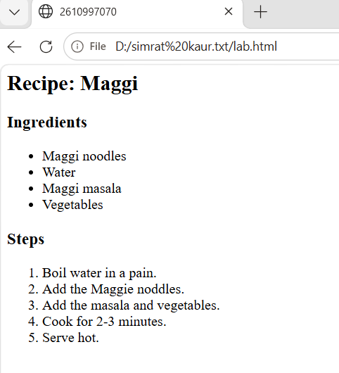

EXPERMINENT NO.4
Question 4: Build a nested list showing a book hierarchy:
Category BooksChapters using <ul> and <ol> together.
Code :
<HTML>
<HEAD>
<TITLE> 2610997070 </TITLE>
</HEAD>
<BODY>
<h2>Book Hierarchy</h2>
<ul>
<li>Programming</li>
<ul>
<li>Python Basics
<ol>
<li>Introduction</li>
<li>Variables</li>
<li>Loops</li>
</ol>
</li>
<li> Web Development
<ol>
<li>HTML</li>
<li>Css</li>
</ol>
</li>
</ul>
</BODY>
</HTML>
Output:

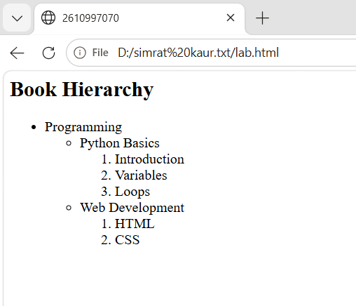

EXPERIMENT NO.5
Question 5: Insert an image using <img> and set src, alt, width, height, and title attributes with valid paths.
Code:
<HTML>
<HEAD>
<TITLE> 2610997070 </TITLE>
</HEAD>
<BODY>
<h2> My Image </h2>
<img src="images.jpg" alt="A beautiful image"
width="350" height="400"
</BODY>
</HTML>
Output:
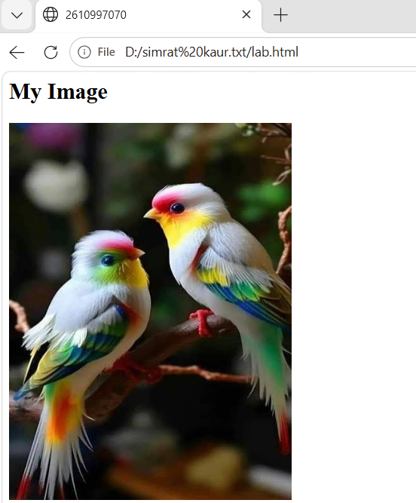

EXPERIMENT NO.6
Question 6: Set a background image for the entire webpage within the <body> tag.
Code:
<HTML>
<HEAD>
<TITLE> 2610997070 </TITLE>
</HEAD>
<BODY background="images (1).jpg">
<h2> My Webpage </h2>
<p> this webpage has a backgrount image.</p>
</BODY>
</HTML>
Output:

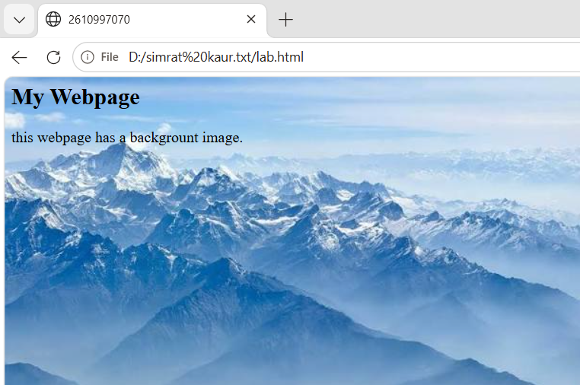

EXPIREMENT NO.7
Question 7: Create internal anchor links that jump to sections on the same page and one external link to a university website.
Code:
<HTML>
<HEAD>
<TITLE> 2610997070 </TITLE>
</HEAD>
<BODY>
<a href="#about">Go to About</a><br>
<a href="#contact">Go to Contact</a><br>
<a href="https://www.chitkara.edu.in/">
Chitkara University</a>
<h2 id="about">About</h2>
<p>This is the about section.</p>
<h2 id="contact">Contact</h2>
<p> This is the contact section.</p>
</BODY>
</HTML>
Output:
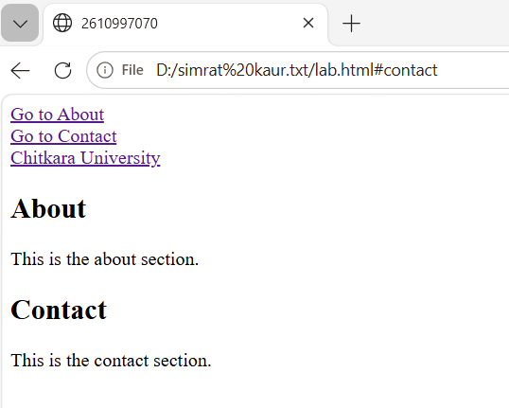

EXPERIMENT NO. 8
Question8: Create internal anchor links and one external link.
Code:
<html>
<head>
<title> 2610997070 </title>
</head>
<body>
<h3>Internal</h3>
<a href="lab class.html"> go to page 1 </a>
<h3>External</h3>
<a href =https://en.wikipedia.org/wiki/Flipkart> visit flipcart </a>
</body>
</html>
Output:

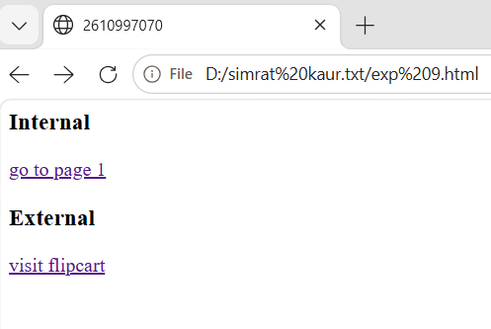

EXPIREMENT NO.9
Question 9: Design an image map with clickable regions.
Code:
<html>
<head>
<title> 2610997070 </title>
</head>
<body>
<img src="india-map.jpg" alt="indian map" width="1463" height="1521" usemap="#india-map”>
<map name="india-map">
<area shape="circle" coords="365,160,45"
href="https://en.wikipedia.org/wiki/Jammu_and_Kashmir_(union_territory)"
alt="Jammu and Kashmir">
<area shape="circle" coords="470,280,35"
href="https://en.wikipedia.org/wiki/Himachal Pradesh"
alt="Himachal Pradesh">
<area shape="circle" coords="390,300,35"
href="https://en.wikipedia.org/wiki/Punjab"
alt="Punjab">
<area shape="circle" coords="420,390,35"
href="https://en.wikipedia.org/wiki/Haryana"
alt="Haryana">

<area shape="circle" coords="460,150,40"
href="https://en.wikipedia.org/wiki/Ladakh"
alt="Ladakh">
<area shape="circle" coords="330,540,70"
href="https://en.wikipedia.org/wiki/Rajasthan"
alt="Rajasthan">
<area shape="circle" coords="200,710,55"
href="https://en.wikipedia.org/wiki/Gujarat"
alt="Gujarat”>
<area shape="circle" coords="600,510,70"
href="https://en.wikipedia.org/wiki/Uttar Pradesh"
alt="Uttar Pradesh">
<area shape="circle" coords="890,560,40"
href="https://en.wikipedia.org/wiki/Bihar"
alt="Bihar">
<area shape="circle" coords="525,690,60"
href="https://en.wikipedia.org/wiki/Madhya Pradesh"
alt="Madhya Pradesh">
<area shape="circle" coords="380,850,65"
href="https://en.wikipedia.org/wiki/Maharashtra"
alt="Maharashtra">
<area shape="circle" coords="720,770,50"
href="https://en.wikipedia.org/wiki/Chhattisgarh"
alt="Chhattisgarh">
<area shape="circle" coords="990,650,40"
href="https://en.wikipedia.org/wiki/ West Bengal"
alt="West Bengal">
<area shape="circle" coords="850,810,45"
href="https://en.wikipedia.org/wiki/Odisha"
alt="Odisha">
<area shape="circle" coords="520,1080,55"
href="https://en.wikipedia.org/wiki/Andhra Pradesh"
alt="Andhra Pradesh">
<area shape="circle" coords="420,1090,55"
href="https://en.wikipedia.org/wiki/Karnataka"
alt="Karnataka">
<area shape="circle" coords="540,350,35"
href="https://en.wikipedia.org/wiki/Uttarakhand"
alt="Uttarakhand”>
<area shape="circle" coords="850,650,40"
href="https://en.wikipedia.org/wiki/Jharkhand"
alt="Jharkhand">
</map>
</body>
</html>
Output:

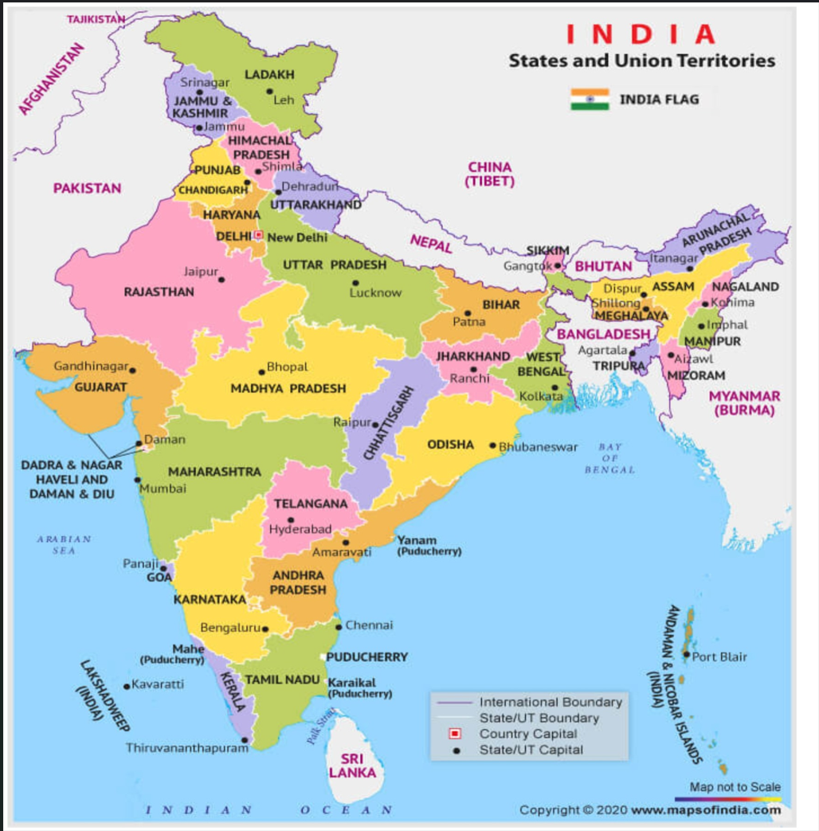

EXPIREMENT NO.10
Question 10: Build a student mark sheet table.
Code:
<html>
<head>
<title>2610997070</title>
</head>
<body>
<table bgcolor="pink" border="4px" height="300px" weidth="600px" cell spacing="2px" cell padding="2px">
<tr>
<td>Sr.No</td>
<td>Name</td>
<td>Roll.no</td>
<td>Marks</td>
</tr>
<tr>
<td>1</td>
<td>Mamta</td>
<td>1</td>
<td>100</td>
</tr>
<tr>
<td>2</td>
<td>Vivek</td>
<td>2</td>
<td>99</td>
</tr>
<tr>
<td>3</td>
<td>Japneet</td>
<td>3</td>
<td>99.5</td>
</tr>
<tr>
<td>4</td>
<td>Ishita</td>
<td>4</td>
<td>95</td>
</tr>
<tr>
<td>5</td>
<td>Swasti</td>
<td>5</td>
<td>66</td>
</tr>
</table>
</body>
</html>
Output:

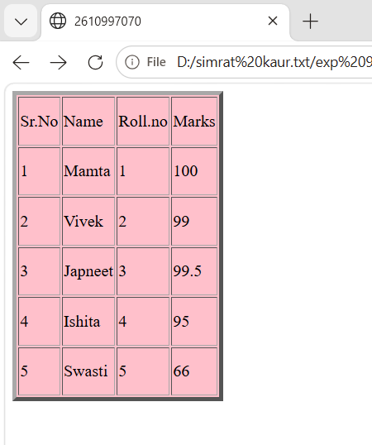

EXPIREMENT NO.11
Question 11: Create a nested timetable table.
Code:
<html>
<head>
<title>2610997070</title>
</head>
<body>
<table border="5" bgcolor="pink">
<tr>
<th colspan="3">Timetable</th>
</tr>

<tr>
<th>Day</th>

<th>
<table border="2">
<tr>
<th>Period</th>
<th>Subject</th>
</tr>
</table>
</th>

<th>Teacher</th>
</tr>

<tr>
<td>Monday</td>

<td>

<table border="2">
<tr>
<td>1</td>
<td>English</td>
</tr>
<tr>
<td>2</td>
<td>Maths</td>
</tr>
<tr>
<td>3</td>
<td>Science</td>
</tr>
</table>
</td>

<td>Mr. Sharma</td>
</tr>

<tr>
<td>Tuesday</td>

<td>

<table border="2">
<tr>
<td>1</td>
<td>Hindi</td>
</tr>
<tr>
<td>2</td>
<td>Computer</td>
</tr>
<tr>
<td>3</td>
<td>Maths</td>
</tr>
</table>
</td>

<td>Mrs. Verma</td>
</tr>

<tr>
<td>Wednesday</td>

<td>

<table border="2">
<tr>
<td>1</td>
<td>Science</td>
</tr>
<tr>
<td>2</td>
<td>English</td>
</tr>
<tr>
<td>3</td>
<td>Computer</td>
</tr>
</table>
</td>

<td>Mr. Kumar</td>
</tr>

</table>

</body>
</html>
Output:

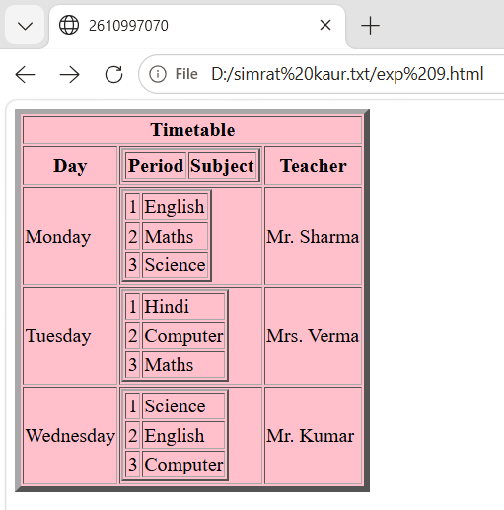

EXPIREMENT NO.12
Question 12: Design a table using rowspan and colspan.
Code:
<html>
<head>
<title>2610997070</title>
</head>
<body>
<table border="4px" cell spacing="2px" cell padding="2px">
<tr>
<th>S. No</th>
<th>Name</th>
<th colspan="2"> Roll.No</th>
<th colspan="3"> Subjects</th>
</tr>

<tr>
<td></td>
<td></td>
<td colspan="2"></td>
<td>Eng</td>
<td>Math</td>
<td>GK</td>
</tr>

<tr>
<td rowspan="2">A</td>
<td>1</td>
<td colspan="2">3</td>
<td>4</td>
<td>6</td>
<td>8</td>
</tr>

<tr>
<td rowspan="2">2</td>
<td>2a, 2b</td>
<td>3a, 3b</td>
<td>5</td>
<td>7</td>
<td>9</td>
</tr>
</table>
</body>
</html>
Output:

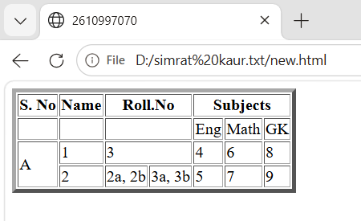

EXPIREMENT NO.13
Question 13: Build a registration form using GET method.
Code :
<html>
<head>
<title>2610997070</title>
</head>
<body bgcolor="pink">
<fieldset>
<legend align="center">STUDENT REGISTERATION FORM</legend>
<form>
<table bgcolor="pink" align="center">
<tr>
<td>FIRST NAME</td>
<td>
<input type="text" maxlength="30">
(max 30 characters a-z and A-Z)
</td>
</tr><br>
<tr>
<td>EMAIL ID</td>
<td>
<input type="email">
</td>
</tr>
<tr>
<td>MOBILE NUMBER</td>
<td>
<input type="text" maxlenght="10">
</td>
</tr>

<tr>
<td>GENDER</td>
<td>
Male <input type="radio" name="gender">
Female <input type="radio" name="gender">
</td>
</tr>

<tr>
<td>ADDRESS</td>
<td>
<textarea rows="4" cols="25"></textarea>
</td>
</tr>

<tr>
<td>CITY</td>
<td>
<input type="text" maxlenght="30">
(max 30 characters a-z and A-Z)
</td>
</tr>

<tr>
<td>PIN CODE</td>
<td>
<input type="text" maxlenght="30">
(6 digit number)
</td>
</tr>

<tr>
<td>STATE</td>
<td>
<input type="text" maxlenght="30">
(max 30 characters a-z and A-Z)
</td>
</tr>

<tr>
<td>COUNTRY</td>
<td>
<input type="text" maxlenght="30" value="India">
</td>
</tr>
<tr>
<td>HOBBIES</td>
<td>
Drawing <input type="checkbox">
Singing <input type="checkbox">
Dancing <input type="checkbox">
Sketching <input type="checkbox">
Others <input type="checkbox">
<input type="text">
</td>
</tr>

<tr>
<td>QUALIFICATION</td>
<td>
<table class="qualification">

<tr align="center">
<td>SL.No</td>
<td>Examination</td>
<td>Boards</td>
<td>Percentage</td>
<td>Year of Passing</td>
</tr>

<tr>
<td>1</td>
<td>Class X</td>
<td>
<input type="text">
</td>
<td>
<input type="text">
</td>
<td>
<input type="text">
</td>
</tr>

<tr>
<td>2</td>
<td>Class Xii</td>
<td>
<input type="text">
</td>
<td>
<input type="text">
</td>
<td>
<input type="text">
</td>
</tr>

<tr>
<td>3</td>
<td>Graduation</td>
<td>
<input type="text">
</td>
<td>
<input type="text">
</td>
<td>
<input type="text">
</td>
</tr>

<tr>
<td>4</td>
<td>Masters</td>
<td>
<input type="text">
</td>
<td>
<input type="text">
</td>
<td>
<input type="text">
</td>
</tr>

</table>
</td>
</tr>

<tr>
<td class="lable">COURSES APPLIED FOR</td>
<td>
BCA
<input type="radio" name="course">

B.Com
<input type="radio" name="course">

B.Sc
<input type="radio" name="course">

B.A
<input type="radio" name="course">
</td>
</tr>
<tr>
<td align="center" colspan="2" class="buttons">
<input type="submit" value="Submit">
<input type="reset" valur="Reset">
</td>
</tr>
</table>
</form>
</fieldset>
</body>
</html>
Output:

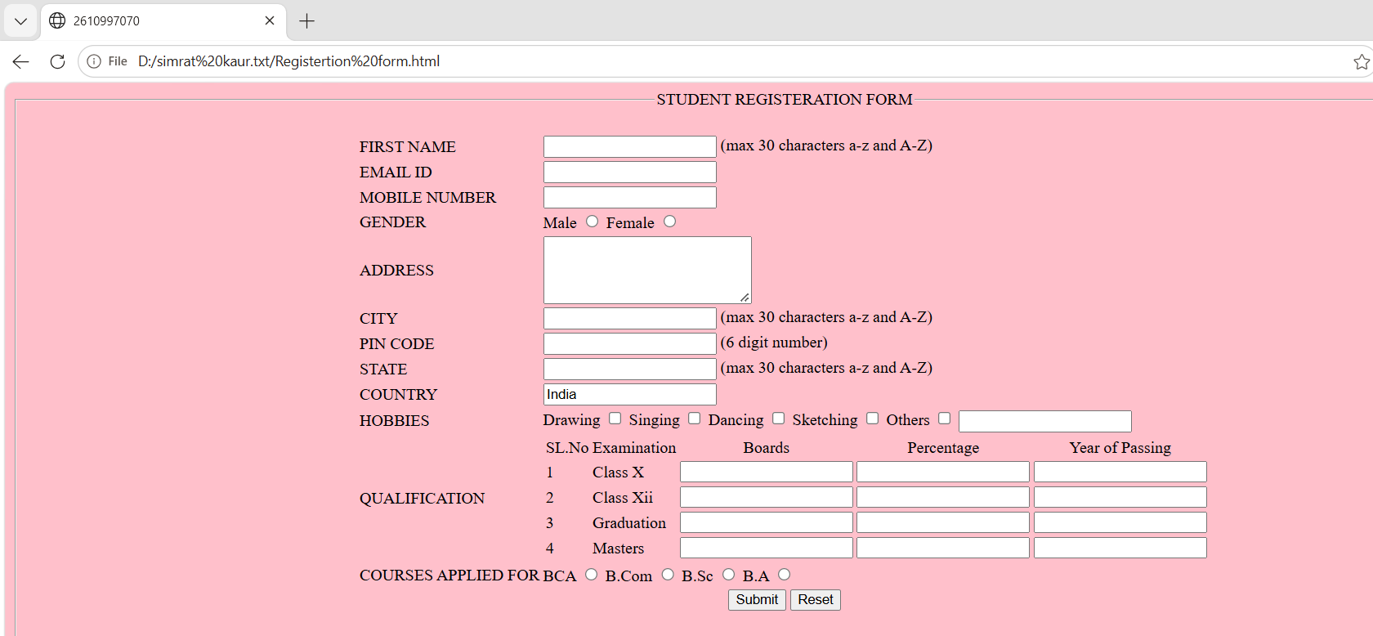

EXPIREMENT NO.14
Question 14: Build a feedback form using POST method.
Code:
<html>
<head>
<title>2610997070</title>
</head>
<body bgcolor="skyblue">
<fieldset>
<form action="submit.php" method="post">
<legend align="center"> <b> HP AGENCY FEEDBACK FORM <b></legend>
<table align="center" cellspacing="4" cellpadding="10">
<tr>
<td> Name </td>
<td><input type="name"> </td>
</tr>
<tr>
<td>Email </td>
<td> <input type="email"></td>
</tr>
<tr>
<td> Address </td>
<td><input type="address"></td>
</tr>
<tr>
<td>Postcode</td>
<td><input type="postcode"> </td>
</tr>
</table>
<table border="1" align="center" cellspacing="2" cellpadding="3">
<tr>
<td>Product</td>
<td> Product Image</td>
<td> Progress Bar</td>
<td>Unit Price</td>
<td>Ratings</td>
</tr>
<tr>
<td> Laptop</td>
<td> <img src= "laptop image.png" width="100" height="80"> </td>
<td> <progress value="50" max="100"> </profress> </td>
<td> $ 900</td>
<td>⭐⭐⭐⭐</td>
</tr>
<tr>
<td> Keyboard</td>
<td> <img src="keyboard image.jpg" width="100" height="80" ></td>
<td><progress value="75" max="100"></progress></td>
<td>$100</td>
<td>⭐⭐⭐⭐⭐</td>
</tr>
<tr>
<td>Mouse</td>
<td><img src ="mouse image.jpg" width="100" height="80"></td>
<td><progress value="20" max="100"></progress></td>
<td>$55</td>
<td>⭐</td>
</tr>
<tr>
<td>Powerbank</td>
<td> <img src="powerbank image.jpg" width="100" height="80" ></td>
<td><progress value="90" max="100"></progress></td>
<td>$289</td>
<td>⭐⭐⭐⭐⭐</td>

</tr>
</table>
<tr>
<td>COMMENT</td>
<td><textarea type="comment"></textarea> </td>
</tr> <br>
<tr><td><button>SUBMIT</button></td></tr>
</table>
</fieldset>
</form>
</body>
</html>
Output:

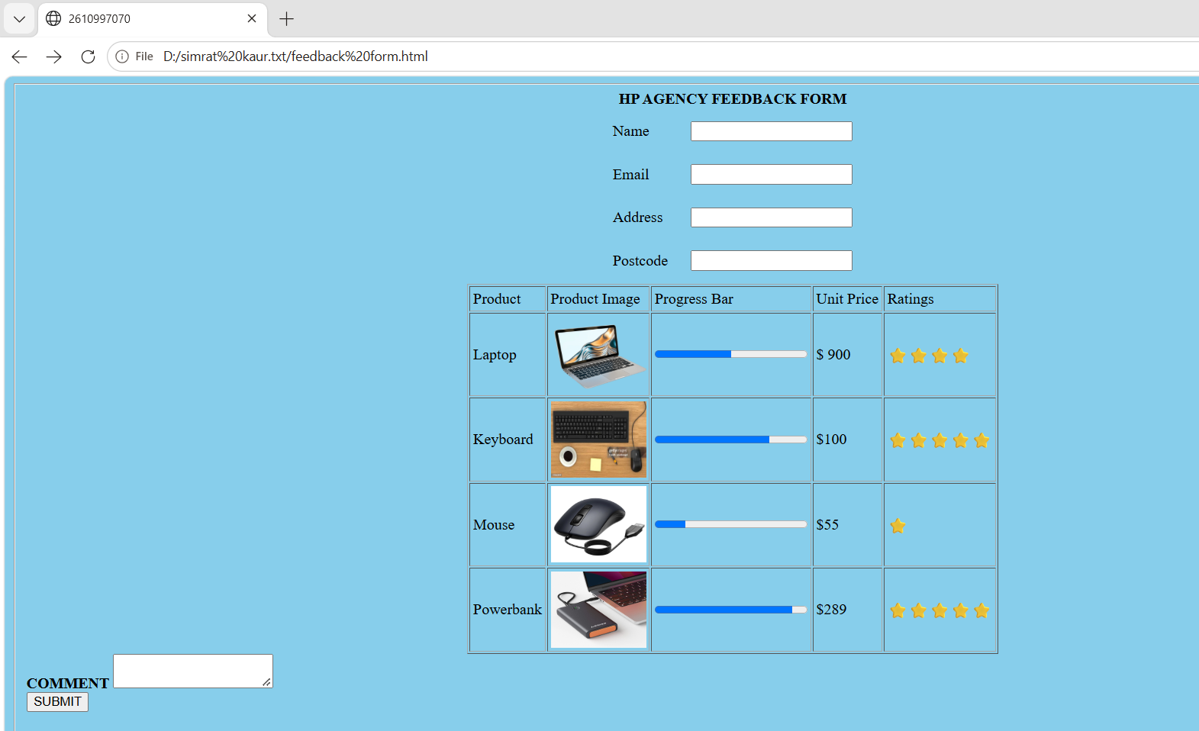

EXPIREMENT NO.15
Question 15: Compare GET and POST forms.
Code:
Features | GET | POST
Form in image | Student registration form | HP agency feedback form
HTML method | Method= GET | Method= POST
Purpose | Sends form data as part of the URL | Sends form data inside the HTTP request body
Visibility | Form data can appear in the browser URL | Form data does not normally appear in the URL
Data size | Limited by URL/browser/server limits | Generally suitable for larger amount of data
Bookmarking | The resulting URL can contain the submitted parameters and can be bookmarked | Submitted form data is not represented in the URL
Typical use | Searching, filtering, retrieving information | Submitting feedback, registration, creating/ updating data
Sensitive information | Should not be used for passwords or sensitive data because values can appear in the URL | Preferable for transmitting sensitive form data, through HTTPS is still required

GET form-
GET form can be written as-
<form action="process.php" method="get">
<input type="text" name="firstname">
<input type="email" name="email">
<input type="submit" value="Submit">
</form>

-When the user submits a GET form, the values are appended to the URL as query parameters.
Example- process.php?firstname=simrat&email=simrat@example.com
-Therefore, GET is commonly used when the form is requesting or filtering information rather than creating/updating data.

POST form-
POST form can be written as-
<form action="process.php" method="post">
<input type="text" name="name">
<input type="email" name="email">
<textarea name="comment"></textarea>
<input type="submit" value="Submit Feedback">
</form>
-When the user submits this form, the form data is sent in the HTTP request body, rather than being appended to the URL.
Example- name=simrat&email=simrat@example.com&comment=Good+service
-The values therefore do not appear in the address bar.
Main Difference-
GET:
Form → URL → Server
POST:
Form → Request Body → Server

Conclusion-
The GET method is appropriate when form data is intended to be part of a URL, such as search or filtering. The POST method is appropriate for submitting information that should be sent in the request body, such as registration, feedback, or data modification. Neither GET nor POST provides encryption by itself; HTTPS is required to protect data during transmission.

EXPIREMENT NO.16
Question 16: Create a frameset with nevigation and content frames.
Code:
<html>
<head>
<title>2610997070</title>
</head>
<body>
<frameset rows="50%,50%">
<frameset cols="50%,50%">
<frame src="resume.html">
<frame src="student regn form.html">
</frameset>
<frameset cols="50%,50%">
<frame src="Hp form.html">
<frame src="index.html">
</frameset>
</frameset>
</body>
</html>
Output:


